Alunos: Alex Aquino

Paulo H. Lopes

1. Multiplica-se dois números em binário usando a matemática convencional. Quando a soma dos termos for 2, coloca 0 no resultado e acumula 1 no próximo número. Se o resultado não preencher as casas decimais do bit resultante, completa com 0.

Tabela Verdade Multiplicador

|  |  |  |  |  |  |  |  |
| --- | --- | --- | --- | --- | --- | --- | --- |
| A1 | A2 | B1 | B2 | **R1** | **R2** | **R3** | **R4** |
| 0 | 0 | 0 | 0 | **0** | **0** | **0** | **0** |
| 0 | 0 | 0 | 1 | **0** | **0** | **0** | **0** |
| 0 | 0 | 1 | 0 | **0** | **0** | **0** | **0** |
| 0 | 0 | 1 | 1 | **0** | **0** | **0** | **0** |
| 0 | 1 | 0 | 0 | **0** | **0** | **0** | **0** |
| 0 | 1 | 0 | 1 | **0** | **0** | **0** | **1** |
| 0 | 1 | 1 | 0 | **0** | **0** | **1** | **0** |
| 0 | 1 | 1 | 1 | **0** | **0** | **1** | **1** |
| 1 | 0 | 0 | 0 | **0** | **0** | **0** | **0** |
| 1 | 0 | 0 | 1 | **0** | **0** | **1** | **0** |
| 1 | 0 | 1 | 0 | **0** | **1** | **0** | **0** |
| 1 | 0 | 1 | 1 | **0** | **1** | **1** | **0** |
| 1 | 1 | 0 | 0 | **0** | **0** | **0** | **0** |
| 1 | 1 | 0 | 1 | **0** | **0** | **1** | **1** |
| 1 | 1 | 1 | 0 | **0** | **1** | **1** | **0** |
| 1 | 1 | 1 | 1 | **1** | **0** | **0** | **1** |

Karnaugh R1

|  |  |  |  |  |
| --- | --- | --- | --- | --- |
| A1 A2/B1 B2 | 00 | 01 | 11 | 10 |
| 00 | 0 | 0 | 0 | 0 |
| 01 | 0 | 0 | 0 | 0 |
| 11 | 0 | 0 | 1 | 0 |
| 10 | 0 | 0 | 0 | 0 |

R1 = A1.A2.B1.B2

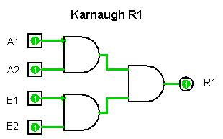

Karnaugh R2

|  |  |  |  |  |
| --- | --- | --- | --- | --- |
| A1 A2/B1 B2 | 00 | 01 | 11 | 10 |
| 00 | 0 | 0 | 0 | 0 |
| 01 | 0 | 0 | 0 | 0 |
| 11 | 0 | 0 | 1 | 1 |
| 10 | 0 | 0 | 1 | 1 |

R2 = A1. $\overline{A2}$.B1 + A1.B1. $\overline{B2}$

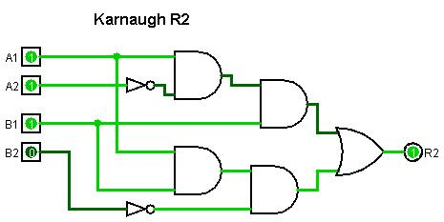

Karnaugh R3

|  |  |  |  |  |
| --- | --- | --- | --- | --- |
| A1 A2/B1 B2 | 00 | 01 | 11 | 10 |
| 00 | 0 | 0 | 0 | 0 |
| 01 | 0 | 0 | 1 | 1 |
| 11 | 0 | 1 | 0 | 1 |
| 10 | 0 | 1 | 1 | 0 |

R3 = A1. $\overline{B1}$.B2 + A1. $\overline{A2}$.B2 + A2.B1. $\overline{B2}$ + $\overline{A1}$.A2.B1

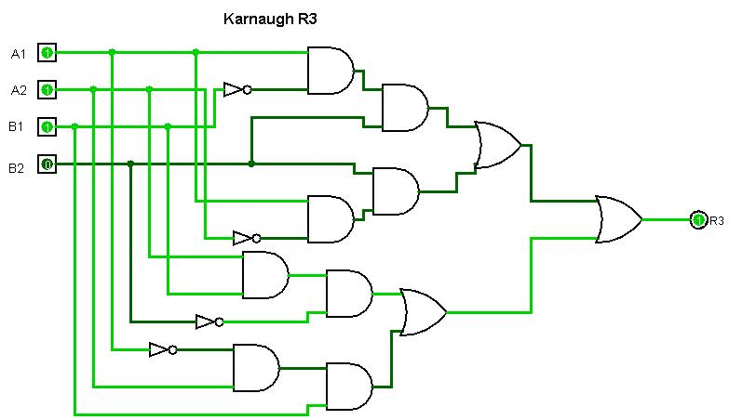

Karnaugh R4

|  |  |  |  |  |
| --- | --- | --- | --- | --- |
| A1 A2/B1 B2 | 00 | 01 | 11 | 10 |
| 00 | 0 | 0 | 0 | 0 |
| 01 | 0 | 1 | 1 | 0 |
| 11 | 0 | 1 | 1 | 0 |
| 10 | 0 | 0 | 0 | 0 |

R4 = A2.B2

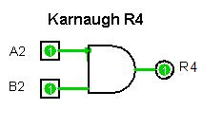

5.

Circuito Final

